Part a: Present relevant summaries and comments

treatment=0

| **Variable** | **N** | **N Miss** | **Mean** | **Variance** |
| --- | --- | --- | --- | --- |
| |  | | --- | | **illness0** | | **illness1** | | **illness3** | | **illness6** | | |  | | --- | | 200 | | 200 | | 200 | | 200 | | |  | | --- | | 0 | | 0 | | 0 | | 0 | | |  | | --- | | 0.94 | | 0.88 | | 0.78 | | 0.69 | | |  | | --- | | 0.06 | | 0.11 | | 0.17 | | 0.22 | |

treatment=1

| **Variable** | **N** | **N Miss** | **Mean** | **Variance** |
| --- | --- | --- | --- | --- |
| |  | | --- | | **illness0** | | **illness1** | | **illness3** | | **illness6** | | |  | | --- | | 200 | | 200 | | 200 | | 200 | | |  | | --- | | 0 | | 0 | | 0 | | 0 | | |  | | --- | | 0.95 | | 0.75 | | 0.47 | | 0.25 | | |  | | --- | | 0.05 | | 0.19 | | 0.25 | | 0.19 | |

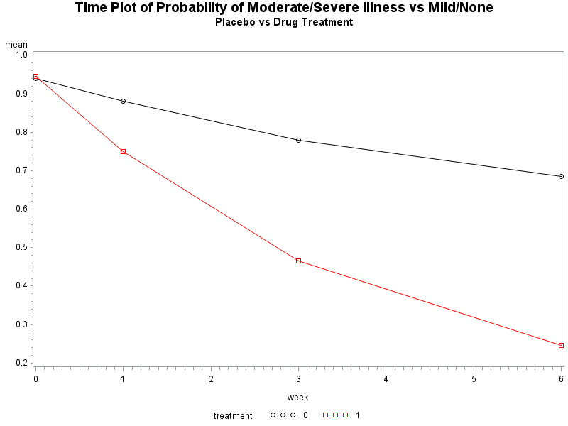

At baseline the placebo group has a probability of increased illness of 94%, while the drug treatment group has a probability of increased illness of 95%. Table 1 and Figure 1 both show that over time the probability of increased illness decreases more rapidly and to lower levels at each time point in the treatment group, vs placebo group. The variability of risk within each group generally increases over time but at not alarmingly different rates across groups. After 6 weeks the treatment group has a mean probability of increased illness of 25% whereas the placebo group has a mean probability of increased illness of 69%.

Part b: Use asymptotic 2-sample test to test null hypothesis of no treatment effect. Do not assume common cov matrix between treatment groups.

The null hypothesis states that the mean vectors in the two treatment groups are equal. The alternative hypothesis is that the mean vectors are not equal. We do not assume a common covariance matrix between groups.

Part c:

Fit the model M1

logit E[Y_ij | b_1i] = beta1 + b_1i + beta2*t_ij + beta3*t_ij*x_i

i = 1...K where K is the number of clusters; j = 1...4 where j is the number of time points

b_1i ... b_1k are unobserved random variables distributed as iid N(0,sigma^2)

assume Y_i1...Y_i4 are conditionally independent given b_1i

Present parameter and empirical (robust, sandwich) SE estimates and 95% confidence intervals

|  |  |  |  |  |  |  |  |  |  |
| --- | --- | --- | --- | --- | --- | --- | --- | --- | --- |
| **Solutions for Fixed Effects** | | | | | | | | | |
| **Effect** | **trt** | **Estimate** | **Standard** | **DF** | **t Value** | **Pr > |t|** | **Alpha** | **Lower CL** | **Upper CL** |
| **Error** |
| **Intercept** |  | 4.5635 | 0.3292 | 399 | 13.86 | <.0001 | 0.05 | 3.9163 | 5.2107 |
| **t** |  | -1.2963 | 0.1417 | 1198 | -9.15 | <.0001 | 0.05 | -1.5742 | -1.0184 |
| **t*treatment** | **1** | -1.4127 | 0.1638 | 1198 | -8.62 | <.0001 | 0.05 | -1.7341 | -1.0913 |

g11 = 5.15

| **Parameter Estimates** | | | | | | | | |
| --- | --- | --- | --- | --- | --- | --- | --- | --- |
| **Parameter** | **Estimate** | **Standard Error** | **DF** | **t Value** | **Pr > |t|** | **95% Confidence Limits** | | **Gradient** |
| **beta1** | 4.5635 | 0.3418 | 399 | 13.35 | <.0001 | 3.8916 | 5.2354 | -6.84E-6 |
| **beta_t** | -1.2963 | 0.1469 | 399 | -8.83 | <.0001 | -1.5851 | -1.0075 | 0.000198 |
| **beta_txtrt** | -1.4127 | 0.1688 | 399 | -8.37 | <.0001 | -1.7445 | -1.0809 | 0.000021 |
| **sigma2** | 5.1518 | 0.9718 | 399 | 5.30 | <.0001 | 3.2413 | 7.0623 | -0.00002 |

Part d: The linear predictor in model M1 contains an interaction between time and treatment but not a main effect of treatment. This is justified because this is a random controlled trial where the baseline probability of illness is the same in both groups. There is no treatment effect at baseline, only over time. If a model shows a statistically significant parameter for treatment, it means the groups were not properly randomized. Including the main effect of treatment allows you to write a contrast statement to test for differences in probability of illness at baseline. Hypotheses about treatment effect over time can be tested using the time by treatment interaction instead of main effects of treatment and main effects at each time point of interest. The probabilities of severe illness at baseline are 94% in the placebo group and 95% in the group receiving the drug, so leaving out main effect of treatment is justified in this analysis. (Note – p119 of textbook – main effects not meaningful in presence of significant trt*time interaction.

Part e: In the context of M1 interpret the estimates of sigma squared, beta2 and beta3.

The estimate of sigma squared for model M1 is 5.15. This value represents the variance of the baseline risk of increased illness in the study population. With a mean risk at baseline of 0.945, we would expect 95% of the study population to have a baseline risk between X and Y. (Create interval).

The estimate of beta2 is -1.296, which is the estimated subject-specific difference in log odds of increased illness after a square root of a week of being in the study, given the same baseline risk. Independent of treatment, on average we would expect the subject-specific log odds of increased illness to change by -1.296.

The estimate of beta3 is -1.413, which is the estimated difference in log odds of increased illness between two different subjects, given the same baseline risk. The estimated value of -1.413 indicates that someone in the drug treatment group is ~0.87 times as likely as someone in the placebo group, to have increased illness after one additional square root of a week in the study, if the two subjects have the same baseline risk.

Part f: Fit the model M2

logit E[Y_ij | b_1i, b_2i] = beta1 + b_1i + beta2*t_ij + beta3*t_ij*x_i + b_2i*t_ij

|  |  |  |  |  |  |  |  |  |  |
| --- | --- | --- | --- | --- | --- | --- | --- | --- | --- |
| **Solutions for Fixed Effects** | | | | | | | | | |
| **Effect** | **trt** | **Estimate** | **Standard** | **DF** | **t Value** | **Pr > |t|** | **Alpha** | **Lower CL** | **Upper CL** |
| **Error** |
| **Intercept** |  | 4.3829 | 0.4333 | 399 | 10.12 | <.0001 | 0.05 | 3.5311 | 5.2348 |
| **t** |  | -1.1313 | 0.206 | 398 | -5.49 | <.0001 | 0.05 | -1.5363 | -0.7263 |
| **t*treatment** | **1** | -1.5629 | 0.2083 | 800 | -7.5 | <.0001 | 0.05 | -1.9719 | -1.15 |

| **Parameter Estimates** | | | | | | | | |
| --- | --- | --- | --- | --- | --- | --- | --- | --- |
| **Parameter** | **Estimate** | **Standard Error** | **DF** | **t Value** | **Pr > |t|** | **95% Confidence Limits** | | **Gradient** |
| **beta1** | 4.3831 | 0.4241 | 398 | 10.34 | <.0001 | 3.5495 | 5.2168 | -0.00059 |
| **beta_t** | -1.1313 | 0.1981 | 398 | -5.71 | <.0001 | -1.5208 | -0.7418 | -0.00311 |
| **beta_txtrt** | -1.5632 | 0.2060 | 398 | -7.59 | <.0001 | -1.9682 | -1.1582 | -0.00273 |
| **sigma11** | 3.9860 | 1.5078 | 398 | 2.64 | 0.0085 | 1.0217 | 6.9504 | -0.00037 |
| **sigma21** | 0.1857 | 0.5511 | 398 | 0.34 | 0.7363 | -0.8978 | 1.2692 | 0.001424 |
| **sigma22** | 0.4540 | 0.4649 | 398 | 0.98 | 0.3294 | -0.4599 | 1.3679 | 0.005153 |

Part g: One of the investigators suggests restricting G in M2 to be diagonal. Discuss whether or not this is a good idea.

The off-diagonal elements of G represent the covariance of baseline risk of illness and change in risk over time. It is of potential interest to know whether baseline risk is associated with change in risk over time so I would recommend not restricting G to a diagonal matrix.

Part h: In the context of M2 test the null hypothesis g22=0 vs alt g22 not equal 0.

In the full model, with random terms for intercept and slope, the -2 log likelihood is 1339.07. In the null model, without a random term for the slope, the -2 log likelihood is 1342.70. The test statistic is the difference in -2 log likelihood between these two models is 3.63. This test statistic follows a distribution that is a 50/50 mixture of chi squared with 1 degree of freedom and a chi squared with 2 degrees of freedom so to calculate the final p value for this test we average the two p values from each of the two distributions. This value is 0.110. At a significance level of 0.05 we do not reject the null hypothesis that g22=0.

Part i: Fit the model M3

logit E[Y_ij] = gamma1 + gamma2*t_ij + gamma3*t_ij*x_i

| **Analysis Of GEE Parameter Estimates** | | | | | | | |
| --- | --- | --- | --- | --- | --- | --- | --- |
| **Empirical Standard Error Estimates** | | | | | | | |
| **Parameter** |  | **Estimate** | **Standard Error** | **95% Confidence Limits** | | **Z** | **Pr > |Z|** |
| **Intercept** |  | 2.7060 | 0.1482 | 2.4156 | 2.9965 | 18.26 | <.0001 |
| **t** |  | -0.7976 | 0.0797 | -0.9538 | -0.6413 | -10.00 | <.0001 |
| **t*treatment** | 1 | -0.7990 | 0.0869 | -0.9694 | -0.6286 | -9.19 | <.0001 |
| **Alpha1** |  | 1.8150 | 0.4072 | 1.0169 | 2.6131 | 4.46 | <.0001 |
| **Alpha2** |  | 1.3850 | 0.4796 | 0.4449 | 2.3251 | 2.89 | 0.0039 |
| **Alpha3** |  | 2.2085 | 0.6258 | 0.9820 | 3.4350 | 3.53 | 0.0004 |
| **Alpha4** |  | 1.8225 | 0.2874 | 1.2591 | 2.3858 | 6.34 | <.0001 |
| **Alpha5** |  | 2.4193 | 0.4166 | 1.6028 | 3.2358 | 5.81 | <.0001 |
| **Alpha6** |  | 2.4039 | 0.3090 | 1.7982 | 3.0096 | 7.78 | <.0001 |

We perform a test of the null hypothesis of no treatment effect over time. This test follows a chi squared distribution with 1 degree of freedom and has a test statistic of 84.44 and an associated p value of <0.0001. We reject the null hypothesis of no treatment effect over time.

Part j: In the context of M3, test the null hypothesis that alpha1=…=alpha6 against the alternative.

[Did not do this section – see other resources]

Part k: Write one of two paragraphs for a medical journal discussing the study design and your main findings.

This analysis shows there is a significant effect of drug treatment over time in reducing probability of increased illness. The variance in baseline risk for this study population [say something here]. The variance in the change in risk over time is [say something], but the variability in the differences in risk over time (slope) was not found to be statistically significant. Thus, we can infer that an individual’s baseline risk may predict their risk over time, but given a baseline risk, the change in risk, on average in the study population, is unlikely to vary widely. We can thus conclude that the drug treatment has a significant effect in reducing risk of increased illness. However, it is worth noting that after 6 weeks of treatment the risk of increased illness in the placebo group decreased from 94% to 69%. This may be due to placebo effect or other unmeasured variation in the placebo group population.